

NATIONAL TECHNICAL PASSPORT


PASSPORT NUMBER :

BHC-2026-xxx
Passport Number will be defined by RACB SPORT

This Passport remains the property of the RACB Sport.
If found, this passport must be sent to:

ROYAL AUTOMOBILE CLUB OF BELGIUM
SPORT DEPARTMENT
BOULEVARD DE LA WOLUWE – 46 – WOLUWEDAL
B-1040 BRUSSELS
BELGIUM

COMPETITOR
Owner Last Name
Owner First Name
Address
Mobile Phone
E-mail

REMINDER
a. This passport does not constitute any proof of compliance to the Series Regulations.
b. Competitors must ensure that their cars comply with the conditions of eligibility and safety throughout the duration of the whole event.
c. The presentation of a car for scrutineering will be deemed an implicit statement of conformity.
d. The absence of this document during scrutineering, as well as the intentional forge, will be considered as fraud, and by consequence may be penalized by an administrative fine defined by the steward of the meeting.
Date
&
Competitor signature
v
Colour Photograph in Landscape
Complete car seen from ¾ Front left
Important: The Competitor bears full responsibility for all the information given on this document.
(Format 13 x 9 cm or 16 x 9 cm)
Please send the pictures by E-mail and
do not convert the file in .PDF please

Colour Photograph in Landscape
Complete car seen from ¾ Rear right
Important: The Competitor bears full responsibility for all the information given on this document.
(Format 13 x 9 cm or 16 x 9 cm)
Please send the pictures by E-mail and
do not convert the file in .PDF please
Colour Photograph in Landscape
Front suspension, side view
Braking system and suspension must be clearly visible
Important: The Competitor bears full responsibility for all the information given on this document.
(Format 13 x 9 cm or 16 x 9 cm)
Please send the pictures by E-mail and
do not convert the file in .PDF please

Colour Photograph in Landscape
Rear suspension, side view
Braking system and suspension must be clearly visible
Important: The Competitor bears full responsibility for all the information given on this document.
(Format 13 x 9 cm or 16 x 9 cm)
Please send the pictures by E-mail and
do not convert the file in .PDF please

Colour Photograph in Landscape
Engine showing all the engine bay from the left side
Important: The Competitor bears full responsibility for all the information given on this document.
(Format 13 x 9 cm or 16 x 9 cm)
Please send the pictures by E-mail and
do not convert the file in .PDF please

Colour Photograph in Landscape
Engine showing all the engine bay from the right side
Important: The Competitor bears full responsibility for all the information given on this document.
(Format 13 x 9 cm or 16 x 9 cm)
Please send the pictures by E-mail and
do not convert the file in .PDF please

CAR
Brand
Model
Chassis N°
Homologation form
Date of manufacture
Class
Weight | kg

ENGINE
Make & Model |  | Type
Position |  | Operating method
Material cylinder block |  | Material cylinder head
Nominal capacity | cc | Corrected capacity (if applicable for turbos x 1.4 or 1.7) | x = cc
Number of cylinders |  | Configuration (straight, V, etc)
Bore | mm | Stroke | mm
Number of plugs per cylinder |  | Number of valves per cylinder
Carburettors |  | Injection make
Type Ignition (breaker / coil, etc) |  | Specify If electronic

ENGINE
Cylinder head | Original  If No  Make  Type | Yes No
Cooling circuit | Original  Fan  Number  Working  Electrical  Mechanical | Yes No  Yes No  Yes No
Lubrication circuit | Original  Radiator  Number  Location | Yes No
Inlet manifold | Original  If No –> Throttle body (etc)  Type  Material | Yes No

FUEL SYSTEM
Type of fuel feed (mechanical, electrical pump) |  | Fuel tank type (original, aluminium, FT3)
Number of pumps |  | Location
Capacity | l

LUBRICATION
Type (wet or dry sump)

GEARBOX
Make & Model |  | Type
Number of forward gears
1st gear (Nb teeth) | / ratio: | 5th gear (Nb teeth) | / ratio:
2nd gear (Nb teeth) | / ratio: | 6th gear (Nb teeth) | / ratio:
3rd gear (Nb teeth) | / ratio: | 7th gear (Nb teeth) | / ratio:
4th gear (Nb teeth) | / ratio: | 8th gear (Nb teeth) | / ratio:
Constant (Nb teeth) | / ratio: | Final drive ratio (Nb teeth) | / ratio:

BRAKES
Make Front |  | Make Rear
Drum diameter Front |  | Drum diameter Rear
Disk diameter Front | mm | Disk diameter Rear | mm
Disk thickness Front | mm | Disk thickness Rear | mm
Material callipers Front |  | Material callipers Rear

WHEELS
Type Front (wire, steel, alloy) |  | Type Rear (wire, steel, alloy)
Diameter Front  in “ | “ | Diameter Rear  in “ | “
Width Front in “ | “ | Width Rear in “ | “

DIMENSIONS
Overall length | mm | Overall width | mm
Width of bodywork (front axle centreline) | mm | Width of bodywork (rear axle centreline) | mm
Wheelbase | mm
Front overhang | mm | Rear overhang | mm

EXTINGUISHER SYSTEM
Manufacturer |  | Type/Model
FIA Homologation N° (if applicable) |  | Validity
Validity after Service 1 |  | Validity after Service 2

SEAT
 | Driver |  | Driver
Manufacturer |  | Type/Model
Homologation N° |  | FIA Standard
Serial N° |  | End of Validity

HARNESS
 | Driver |  | Driver
Manufacturer |  | Type/Model
Homologation N° |  | FIA Standard
Serial N° |  | End of Validity

SAFETY FUEL TANK
Manufacturer |  | Type/Model
Homologation N° |  | Capacity | l
Serial N° |  | End of Validity

SAFETY CAGE
This document is not a safety cage certificate
Homologation |  | FIA Homologation certificate #  ASN Homologation certificate #  Not homologated, built and mounted following Appendix K or J253  Appendix K  Appendix J
Installation |  | Welded  Bolted
DIMENSIONS
 |  | Outside diameter |  | Thickness |  | Material
Main rollbar |  | mm |  | mm
Front rollbar |  | mm |  | mm
Longitudinal members |  | mm |  | mm
Transversal members |  | mm |  | mm
Diagonal members |  | mm |  | mm
USED SCHEMES
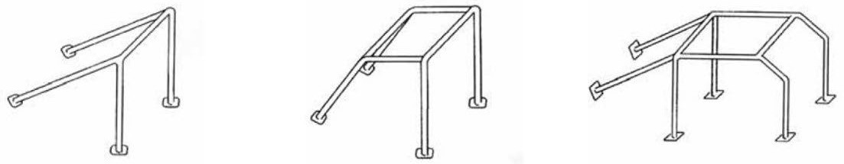

K-1 K-2 K-3

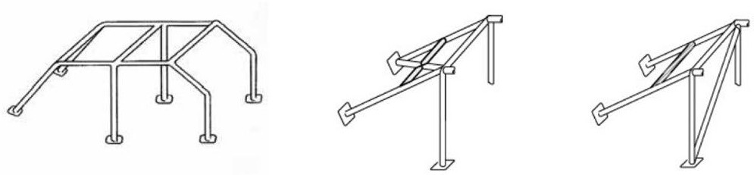

K-4 K-5 K-6

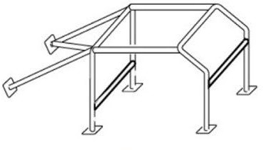

K-7

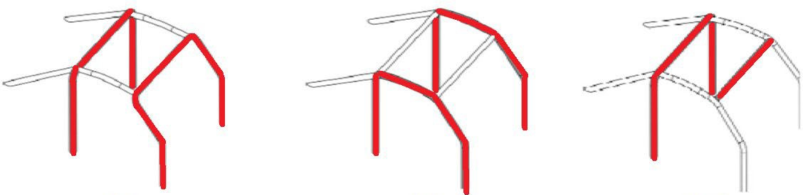

K-8 / J 253-1 K-9 / J 253-2 K-10 / J 253-3

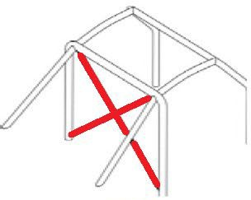
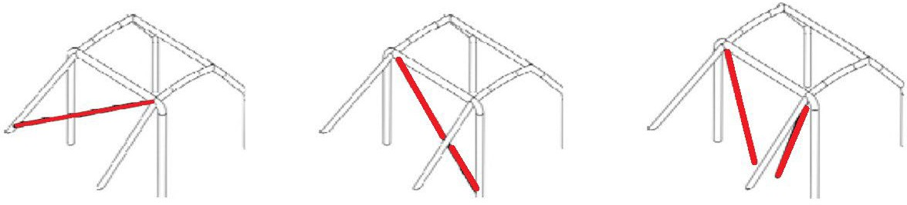

K-11 / J 253-4 K-12 / J 253-5 K-13 / J 253-6 K-10 / J 253-7

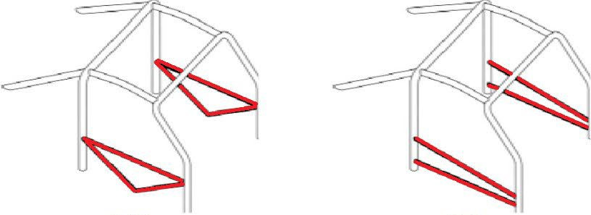
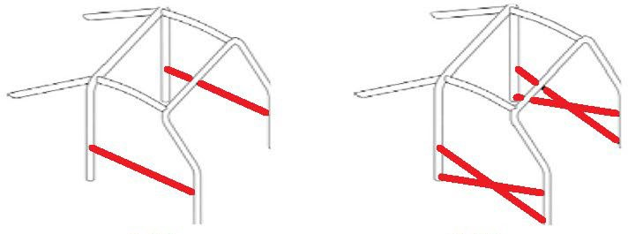

K-15 / J 253-8 K-16 / J 253-9 K-17 / J 253-10 K-18 / J 253-11

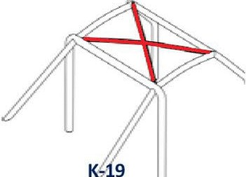
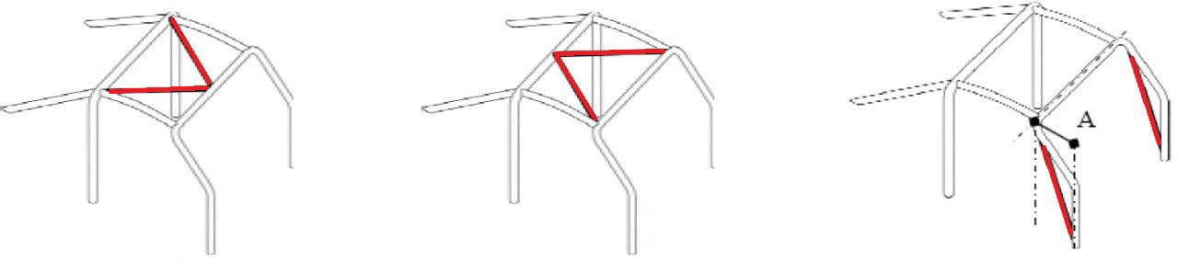

K-19 / J 253-12 K-20 / J 253-13 K-21 / J 253-14 K-22 / J 253-11

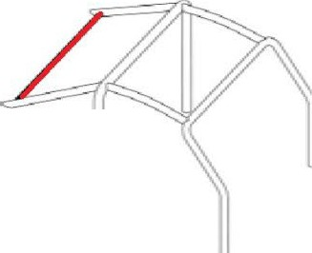
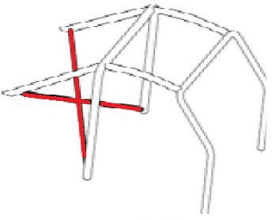
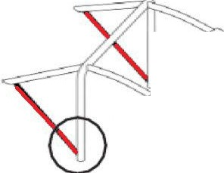
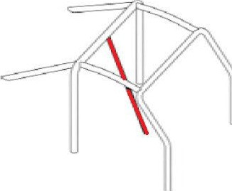

K-23 / J 253-16 K-24 / J 253-17 K-25 / J 253-18 K-26 / J 253-19

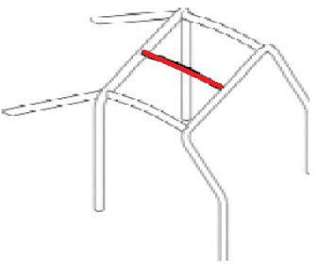
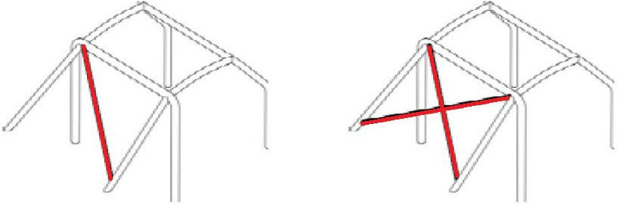

K-27 / J 253-20 K-28 / J 253-21 J 253-22 K-29 / J 253-23

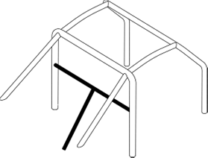
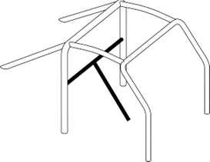
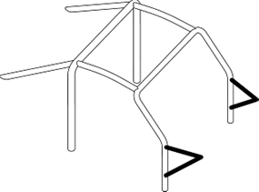
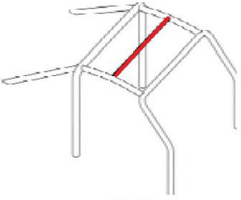

K-30 / J 253-24 J 253-25 J253-26 J 253-27

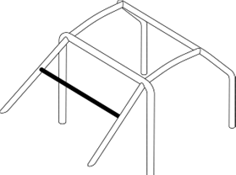

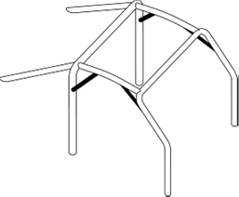
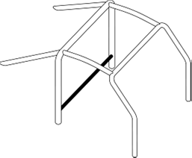
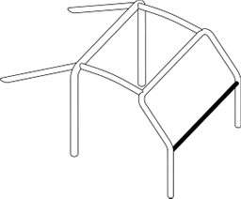

J 253-28 K-31 / J 253-29 K-32 / J253-30 K-33 / J 253-31

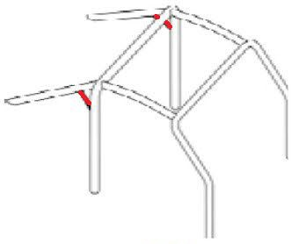
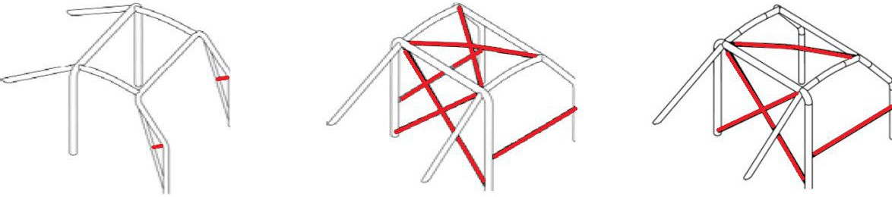

K-34 / J253-32 K-35 / J 253-33 K-36 / J253-35B K-37 / J 253-36



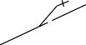
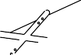
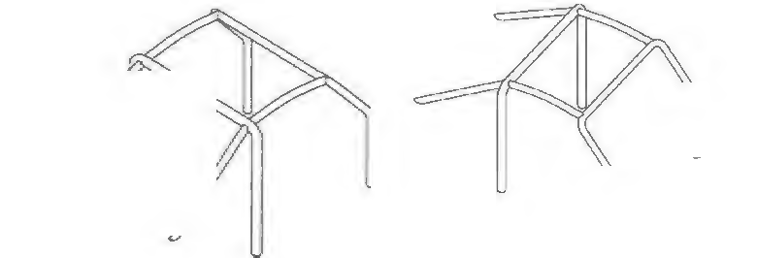
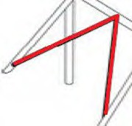
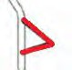
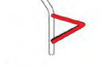

K-34 / J253-32 K-35 / J 253-33 235J-66 J 253-66

EVENTS LIST
Date | Name of the Event |  | Car Number |  | Scrutineer & signature |  | Initial Scrutineering
 |  |  |  |  |  |  | OK | Not OK  (see remarks)
 |  |  |  |  |  |  | OK | Not OK  (see remarks)
 |  |  |  |  |  |  | OK | Not OK  (see remarks)
 |  |  |  |  |  |  | OK | Not OK  (see remarks)
 |  |  |  |  |  |  | OK | Not OK  (see remarks)
 |  |  |  |  |  |  | OK | Not OK  (see remarks)
 |  |  |  |  |  |  | OK | Not OK  (see remarks)
 |  |  |  |  |  |  | OK | Not OK  (see remarks)
 |  |  |  |  |  |  | OK | Not OK  (see remarks)
 |  |  |  |  |  |  | OK | Not OK  (see remarks)
 |  |  |  |  |  |  | OK | Not OK  (see remarks)
 |  |  |  |  |  |  | OK | Not OK  (see remarks)
 |  |  |  |  |  |  | OK | Not OK  (see remarks)
 |  |  |  |  |  |  | OK | Not OK  (see remarks)
 |  |  |  |  |  |  | OK | Not OK  (see remarks)
 |  |  |  |  |  |  | OK | Not OK  (see remarks)
 |  |  |  |  |  |  | OK | Not OK  (see remarks)

EVENTS LIST
Scrutineering remarks | Competitor signature
Passport validated after pre-inspection

EVENTS LIST
Date | Name of the Event | Car Number | Scrutineer & signature | Initial Scrutineering
 |  |  |  | OK | Not OK  (see remarks)
 |  |  |  | OK | Not OK  (see remarks)
 |  |  |  | OK | Not OK  (see remarks)
 |  |  |  | OK | Not OK  (see remarks)
 |  |  |  | OK | Not OK  (see remarks)
 |  |  |  | OK | Not OK  (see remarks)
 |  |  |  | OK | Not OK  (see remarks)
 |  |  |  | OK | Not OK  (see remarks)
 |  |  |  | OK | Not OK  (see remarks)
 |  |  |  | OK | Not OK  (see remarks)
 |  |  |  | OK | Not OK  (see remarks)
 |  |  |  | OK | Not OK  (see remarks)
 |  |  |  | OK | Not OK  (see remarks)
 |  |  |  | OK | Not OK  (see remarks)
 |  |  |  | OK | Not OK  (see remarks)
 |  |  |  | OK | Not OK  (see remarks)
 |  |  |  | OK | Not OK  (see remarks)

EVENTS LIST
Scrutineering remarks | Competitor signature

EVENTS LIST
Date | Name of the Event | Car Number | Scrutineer & signature | Initial Scrutineering
 |  |  |  | OK | Not OK  (see remarks)
 |  |  |  | OK | Not OK  (see remarks)
 |  |  |  | OK | Not OK  (see remarks)
 |  |  |  | OK | Not OK  (see remarks)
 |  |  |  | OK | Not OK  (see remarks)
 |  |  |  | OK | Not OK  (see remarks)
 |  |  |  | OK | Not OK  (see remarks)
 |  |  |  | OK | Not OK  (see remarks)
 |  |  |  | OK | Not OK  (see remarks)
 |  |  |  | OK | Not OK  (see remarks)
 |  |  |  | OK | Not OK  (see remarks)
 |  |  |  | OK | Not OK  (see remarks)
 |  |  |  | OK | Not OK  (see remarks)
 |  |  |  | OK | Not OK  (see remarks)
 |  |  |  | OK | Not OK  (see remarks)
 |  |  |  | OK | Not OK  (see remarks)
 |  |  |  | OK | Not OK  (see remarks)

EVENTS LIST
Scrutineering remarks | Competitor signature

EVENTS LIST
Date | Name of the Event | Car Number | Scrutineer & signature | Initial Scrutineering
 |  |  |  | OK | Not OK  (see remarks)
 |  |  |  | OK | Not OK  (see remarks)
 |  |  |  | OK | Not OK  (see remarks)
 |  |  |  | OK | Not OK  (see remarks)
 |  |  |  | OK | Not OK  (see remarks)
 |  |  |  | OK | Not OK  (see remarks)
 |  |  |  | OK | Not OK  (see remarks)
 |  |  |  | OK | Not OK  (see remarks)
 |  |  |  | OK | Not OK  (see remarks)
 |  |  |  | OK | Not OK  (see remarks)
 |  |  |  | OK | Not OK  (see remarks)
 |  |  |  | OK | Not OK  (see remarks)
 |  |  |  | OK | Not OK  (see remarks)
 |  |  |  | OK | Not OK  (see remarks)
 |  |  |  | OK | Not OK  (see remarks)
 |  |  |  | OK | Not OK  (see remarks)
 |  |  |  | OK | Not OK  (see remarks)

CHANGE IN OWNERSHIP

Owner First & LAST Name
Address
PC - City
Mobile Phone
E-mail

Owner First & LAST Name
Address
PC - City
Mobile Phone
E-mail

Owner First & LAST Name
Address
PC - City
Mobile Phone
E-mail

Owner First & LAST Name
Address
PC - City
Mobile Phone
E-mail

ROYAL AUTOMOBILE CLUB OF BELGIUM

